UK DPA 2018 Compliance for Log360
Strengthen data protection and meet UK DPA 2018 compliance with Log360.
Region: EU, UK | Type: Data Privacy | Category: Compliance | Pricing: Free

Overview
The UK DPA 2018 compliance extension in Log360 helps organizations meet the United Kingdom Data Protection Act 2018, the UK's domestic GDPR implementation governing all controllers and processors handling UK residents' personal data by providing centralized log management, real-time threat detection, and comprehensive audit trail collection. The platform supports UK DPA 2018 requirements for security of processing, breach notification, mandatory audit logging, data subject rights tracking, controller accountability, special category data protection, DPIA evidence, and ICO enforcement readiness.
For Data Protection Principles and Accountability, Log360 generates audit trails across all processing systems to demonstrate lawful, purpose-limited data handling and document the accountability principle. To address Security of Processing, the platform provides authentication monitoring, network security events, endpoint threat detection, and privilege escalation alerts as primary technical controls evidencing Article 32 compliance. The extension also supports Personal Data Breach Notification by providing capabilities that Log360's real-time alerting and threat detection accelerate breach discovery and provide incident timelines and documentation required for mandatory ICO notification.

Key Features
- Mandatory Audit Logging Requirements: Log360 captures detailed user access logs, file audit trails, and database activity reports that directly fulfil the granular Section 62 logging requirements.
- Data Subject Rights Evidence: Log360 provides user activity logs, file access reports, and account management records to evidence timely, accurate data subject rights fulfilment.
- Controller and Processor Accountability: Log360 provides GPO auditing, user management logs, and EventLog records as the technical accountability evidence layer for ROPA documentation and ICO examination.
- Special Category Data Protection: Log360 monitors privileged access to sensitive repositories, file access failures, and USB events to detect unauthorized access to special category data.

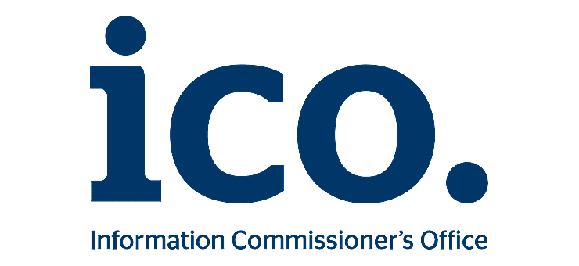
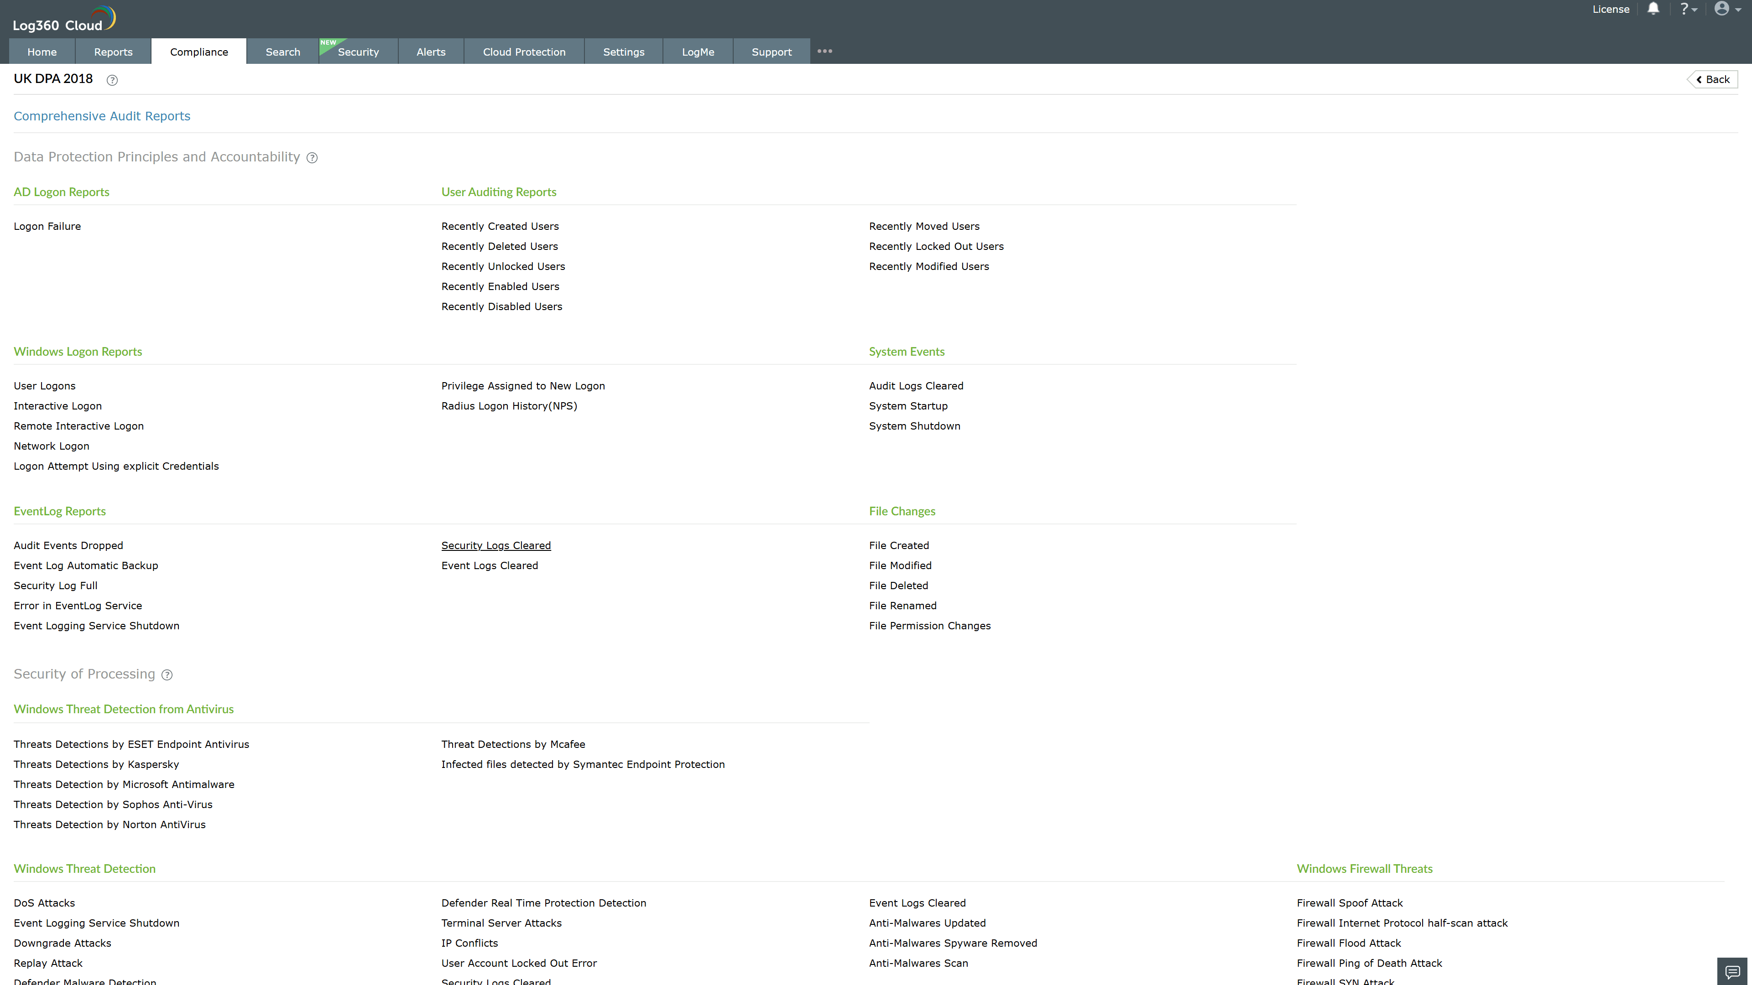
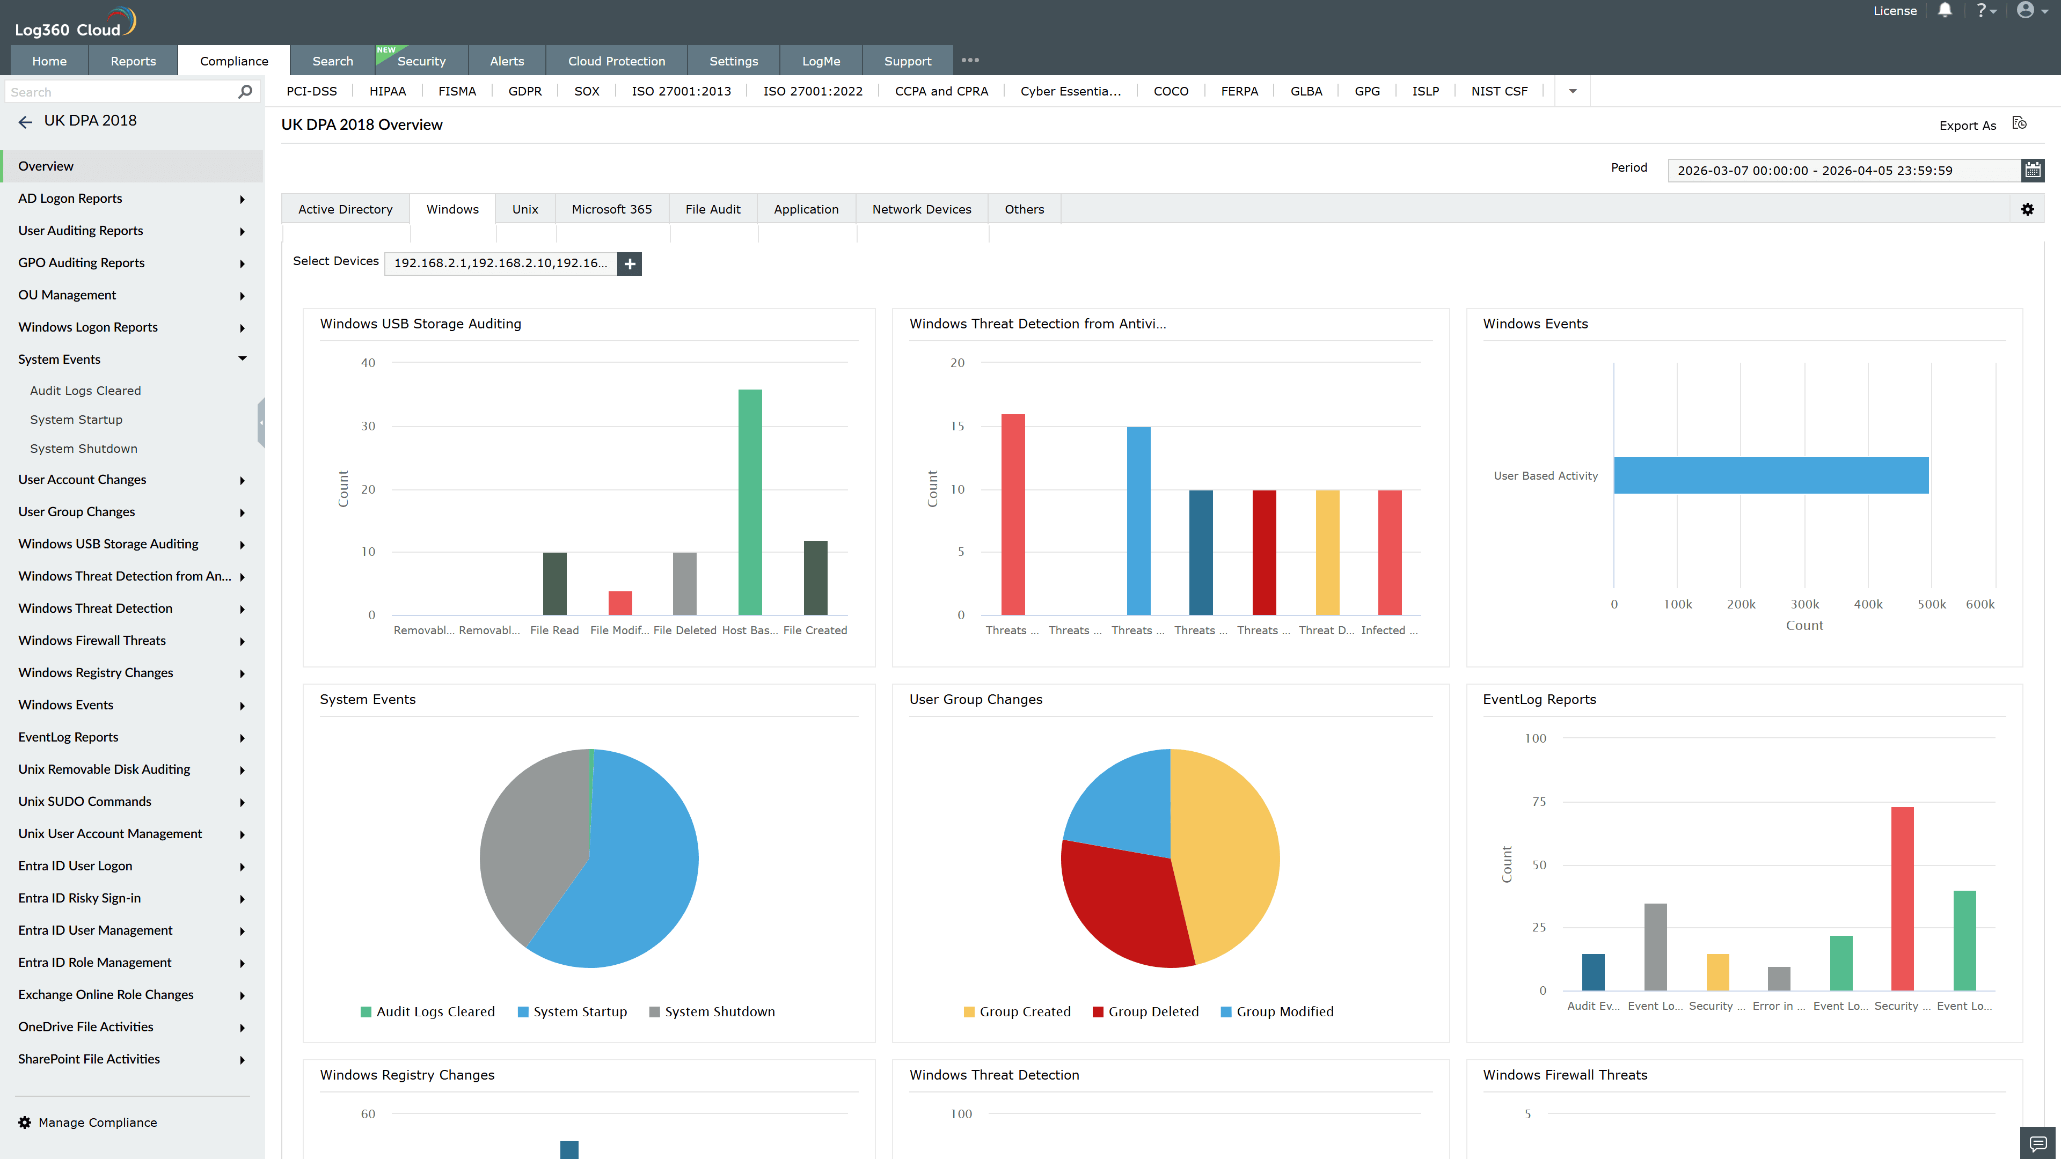
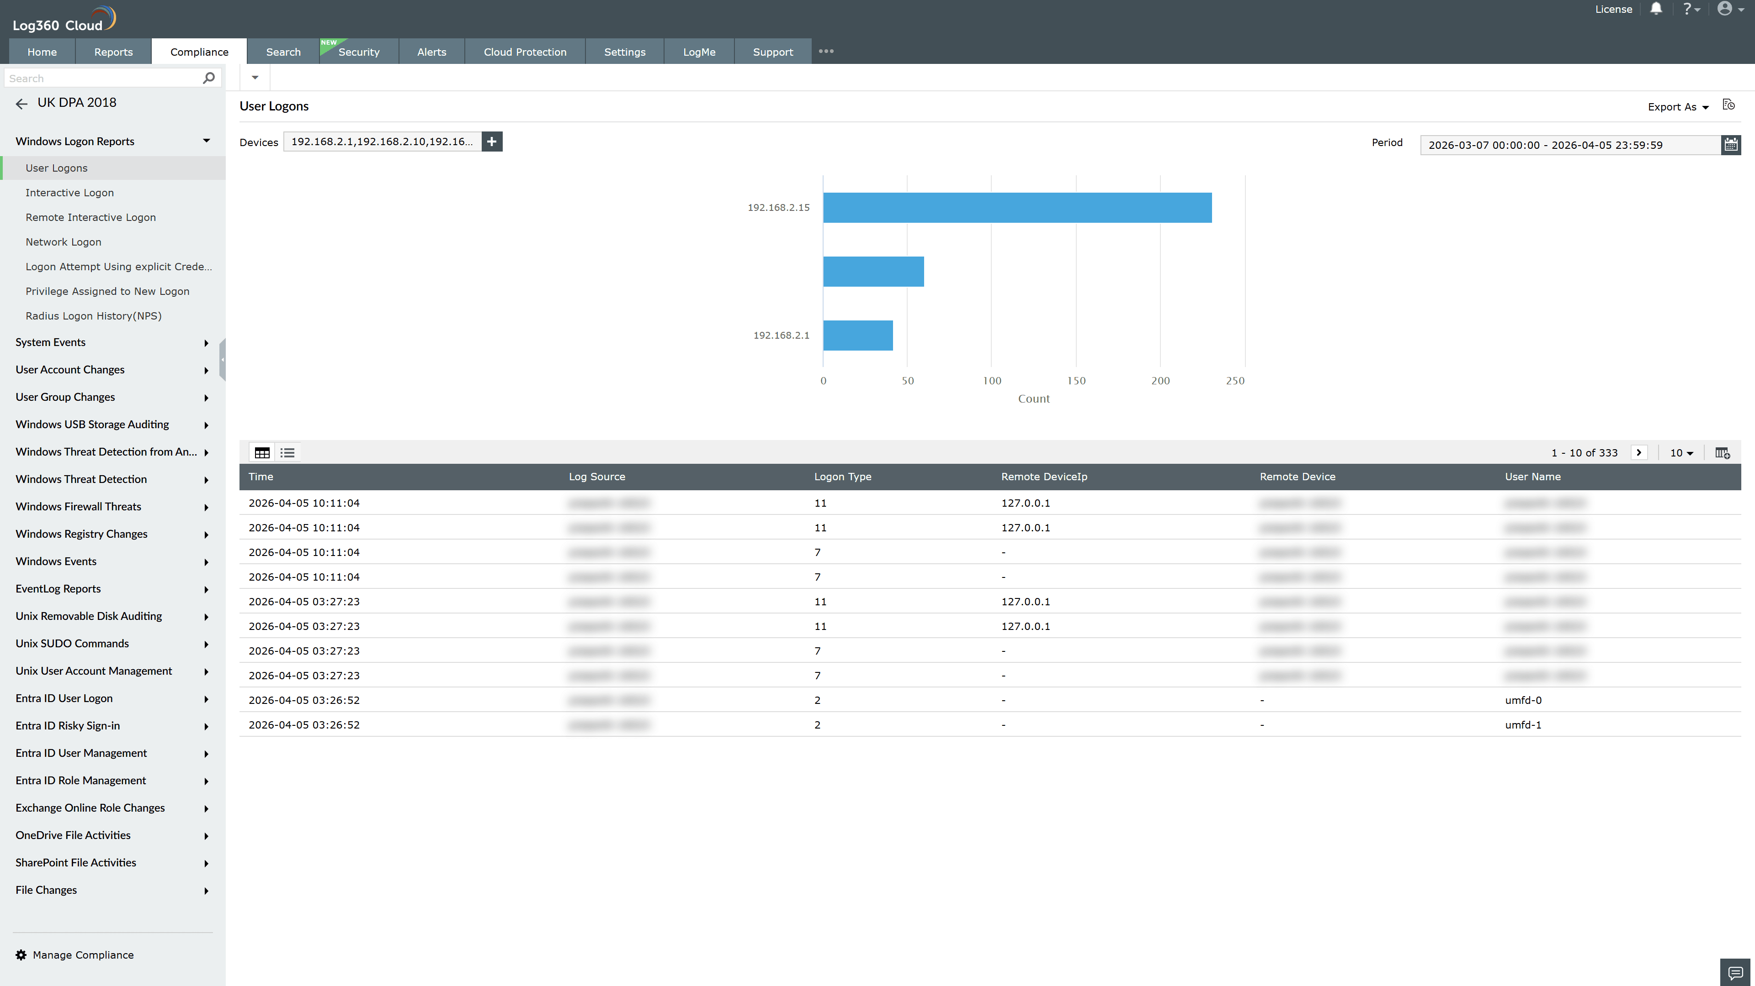
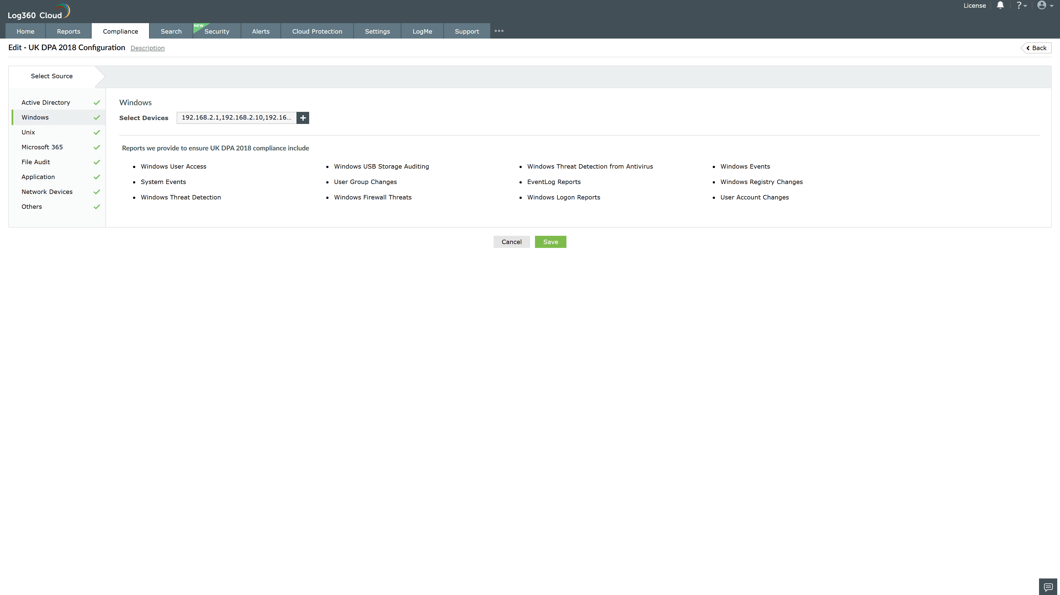
Valid Submission : Yes
Supported Editions : Free, Basic, Standard, Professional, MSSP
Help Document : https://www.manageengine.com/log-management/help/integrations/compliance-extensions.html
Help Video : Not provided
Tags : Log360, Compliance, Privacy monitoring, Data privacy, Regulatory compliance
Supported DCs : US, IN, JP, CA, AU, UK and EU
Privacy Policy:
Terms of Service:
Release Notes:
Predefined reports for the UK DPA 2018.

